Software Construction

and Development

Experiment 01
Introduction to UML Modelling and Obeject Oriented Concepts

CLO 1: Apply software construction principles, object-oriented concepts, and UML modeling techniques to design and represent software system structure and behavior using appropriate tools and standard practices.

CLO 2: Design and implement original solutions to given software problems by applying modeling, design, and construction techniques discussed in the lab.

CLO 3: Demonstrate effective teamwork and individual contribution during software modeling and construction activities to develop well-structured and understandable software designs.

Purpose:
This experiment provides an introduction to Unified Modeling Language. Student will get basic introduction of the diagrams available for system modeling. StarUML modelling tool will also be introduced in this lab.

Objectives:

At the end of this experiment you will

- Explain core Object-Oriented (OO) concepts as represented in UML
- Identify and differentiate UML 2.x diagram types
- Use UML diagrams to model basic software systems
- Draw basic UML diagrams using standard notations and tools

Equipment and Components:

- StarUML v4.1.2
- Microsoft Visio Professional 2023

- Introduction to UML

1.1 What is UML?
The Unified Modeling Language (UML) is a standardized visual modeling language used to specify, visualize, construct, and document the artifacts of a software system. UML is widely used in object-oriented analysis and design and provides a common language for developers, designers, and stakeholders.
UML helps to:
- Visualize system structure and behavior
- Communicate design ideas effectively
- Reduce system complexity
- Document software designs before implementation
1.2 Importance of UML in Software Construction
- Acts as a blueprint before coding begins
- Helps detect design issues early
- Improves maintainability and scalability
- Facilitates communication among team members and clients
2. Object-Oriented Concepts Used in UML
2.1 Class
A class is a blueprint for creating objects. It defines attributes (data members) and methods (member functions).
Example:
- Class: Student
- Attributes: id, name, age
- Methods: enroll(), display()

2.2 Object
An object is an instance of a class with specific attribute values.
Example:
- student1 : Student

2.3 Encapsulation
Encapsulation is the bundling of data and methods together while restricting direct access to internal details.
UML Visibility Notations:
- + Public
- - Private
- # Protected

2.4 Inheritance
Inheritance allows a subclass to acquire properties and behaviors of a superclass.
Example:
Person
↑
Student

2.5 Polymorphism
Polymorphism allows the same method name to behave differently for different objects.
Example:
- Method calculateFee() behaves differently for Undergraduate and Graduate students
2.6 Abstraction
Abstraction focuses on essential features while hiding unnecessary implementation details.
Example:
- Abstract class Shape with abstract method draw()

3. UML and Software Development Life Cycle
UML can be used throughout the Software Development Life Cycle (SDLC). It is not a methodology but a modeling language that supports requirement analysis, system design, implementation, and documentation.
UML models represent multiple views of a system, collectively known as a UML Model, describing what a system is supposed to do.

4. UML 2.x Diagram Types (12 Diagrams)
UML 2.x defines 12 standard diagrams, categorized into Structural and Behavioral diagrams.
- Structure diagrams
- Behavior diagrams

4.1 Structure diagrams
It show the static structure of the system and its parts on different abstraction and implementation levels and how they are related to each other. The elements in a structure diagram represent the meaningful concepts of a system, and may include abstract, real world and implementation concepts, there are seven types of structure diagram as follows:
- Class Diagram
- Object/Component Diagram
- Deployment Diagram
- Object Diagram
- Package Diagram
- Composite Structure Diagram

4.2 Behavior diagrams
It show the dynamic behavior of the objects in a system, which can be described as a series of changes to the system over time, there are seven types of behavior diagrams as follows:

- Use Case Diagram
- Activity Diagram
- State Machine Diagram
- Sequence Diagram
- Communication Diagram
- Interaction Overview Diagram
- Timing Diagram
5. Brief Description of Key UML Diagrams.
Class Diagram:
A class is a category or group of things that have the same attributes and the same behaviors. A rectangle is the icon that represents the class. It’s divided into three areas. The uppermost area contains the name, the middle area holds the attributes, and the lowest area holds the operations i.e Anything in the class of washing machines has attributes such as brand name, model, serial number, and capacity. Behaviors for things in this class include the operations “accept clothes,” “accept detergent,” “turn on,” and “turn off.” In UML, a multiword classname has initial capital letters for all the words and eliminates white space between each word (for example, WashingMachine). Attribute names and operation-names follow the same convention, but the first letter of the first word isn’t capitalized (for example, acceptClothes ()).
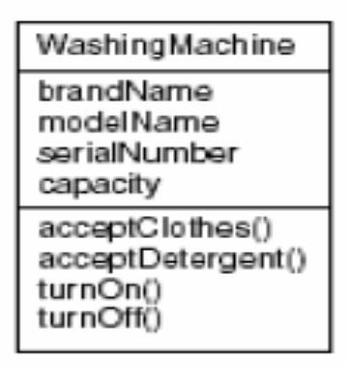
Figure 01: class diagram of washing machine
Object Diagram:
An object is an instance of a class—a specific thing that has specific values of the class’s attributes. The icon is a rectangle, just like the class icon, but the name is underlined. In the icon on the left, the name of the specific instance is on the left side of a colon, and the name of the class is on the right side of the colon. The name of the instance begins with a lowercase letter. It’s also possible to have an anonymous object, as the icon on the right of Figure shows. This just means that you don’t supply a specific name for the object, although you do show the class it belongs to.
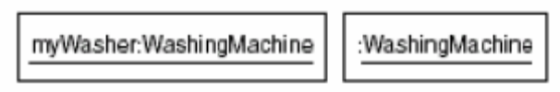
Figure 02: object diagram of washing machine
Use Case Diagram:
A use case is a description of a system’s behavior from a user’s standpoint. For system developers, the use case is a valuable tool: It’s a tried-and-true technique for gathering system requirements from a user’s point of view. Obtaining information from the user’s point of view is important if the goal is to build a system that real people can use. The little stick figure that corresponds to the washing machine user is called an actor. The ellipse represents the use case. The actor—the entity that initiates the use case—can be a person or another system. The use case is inside a rectangle that represents the system, and the actor is outside the rectangle.
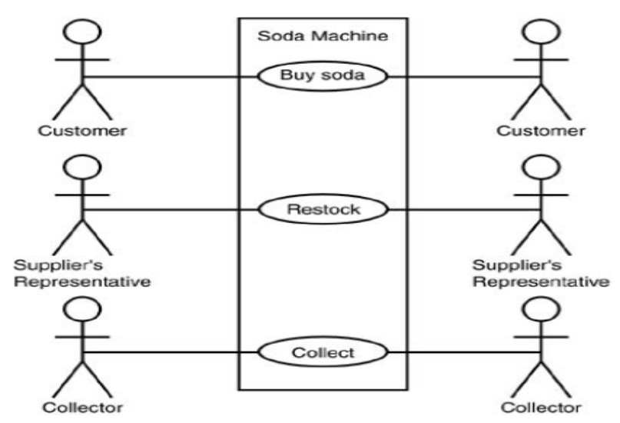
Figure 03: A use case model of the soda machine
State Diagram:
At any given time, an object is in a particular state. This transition from one state to the next state is represented by state diagram.i.e A person can be a newborn, infant, child, adolescent, teenager, or adult. An elevator is either moving or stationary. A washing machine can be either in the soaking, washing, rinsing, spinning, or off state. The symbol at the top of the figure represents the start state and the symbol at the bottom represents the end state.
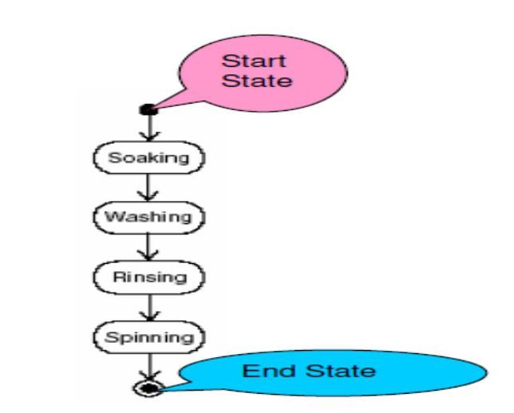
Figure 04: State diagram of washing machine
Communication Diagram:
Both the sequence diagram and the communication diagram show interactions among objects. For this reason, the UML refers to them collectively as interaction diagrams.
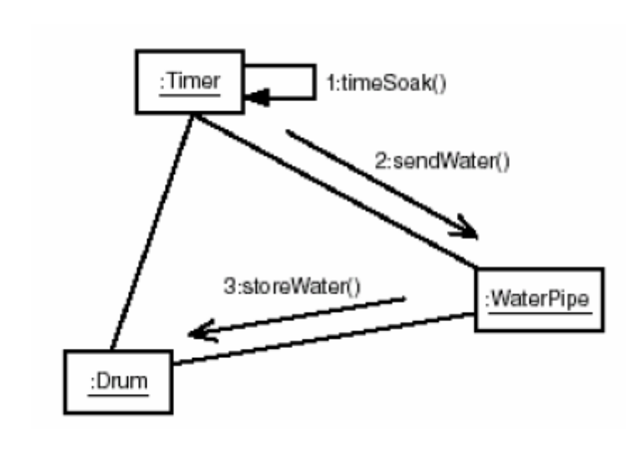
Figure 05: Communication Diagram of washing machine
Sequence Diagram:
Objects interact with one another, and these interactions occur over time. The UML sequence diagram shows the time-based dynamics of the interaction.Arrow represents a message that goes from one object to another. Time, in this diagram, proceeds from top to bottom. So the first message is timeSoak (), which the timer sends to itself. The second message is sendWater (), which the timer sends to the water pipe. The final message, stopRotating (), goes from the timer to the drum.
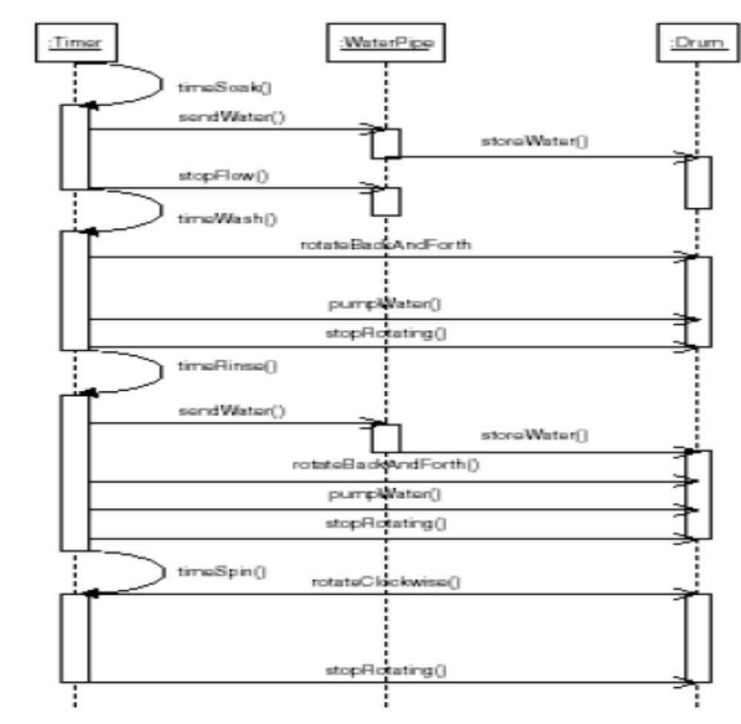
Figure 06: Sequence diagram of washing machine

Activity Diagram:
The activities that occur within a use case or within an object’s behavior typically occur in a sequence is represented by the activity diagram.
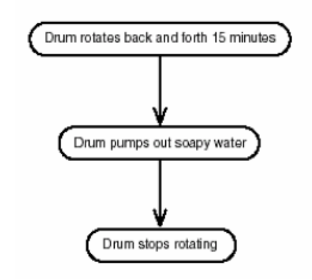
Figure 07: Activity diagram of washing machine
Deployment Diagram:
The name Deployment itself describes the purpose of the diagram. Deployment diagrams are used for describing the hardware components where software components are deployed. Component diagrams and deployment diagrams are closely related. Component diagrams are used to describe the components and deployment diagrams shows how they are deployed in hardware. Contents: Nodes, Dependency & Association relationships.
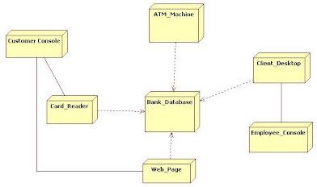
Figure 08: Deployement diagram
Composite Structure Diagram:
Each component class inside the whole is called the composite structure Diagram.i.e a person consists of a mind and a body. It consists of lines and symbols that join the Person class to the Mind class and to the Body class.
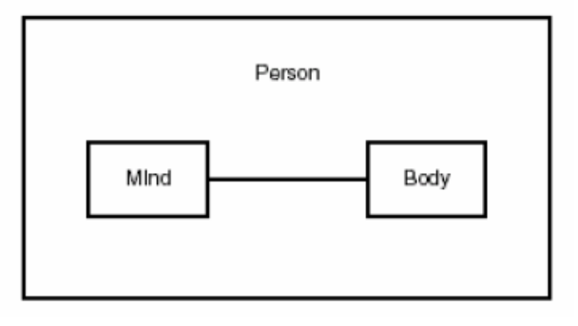
Figure 09: Composite Structure Diagram of Person
Timing Diagram:
Timing diagram is designed to show how long an object is in a state.

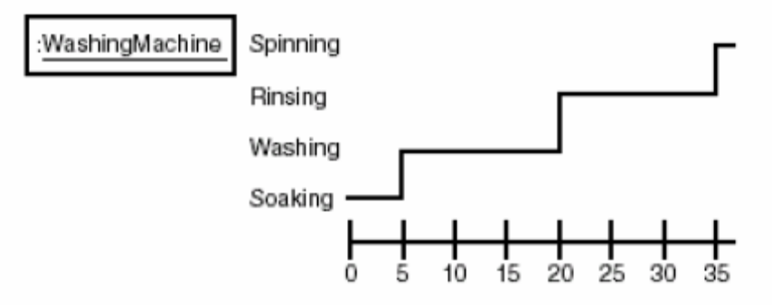
Figure 10: Timing diagram of washing machine
Interaction Overview Diagram:
If you replaced some of the activities with sequence diagrams or communication diagrams (or a combination of the two), you’d have UML 2.0’s new interaction overview diagram.The Interaction Overview Diagram focuses on the overview of the flow of control of the interactions. It is a variant of the Activity Diagram where the nodes are the interactions or interaction occurrences. The Interaction Overview Diagram describes the interactions where messages and lifelines are hidden. You can link up the "real" diagrams and achieve high degree navigability between diagrams inside the Interaction Overview Diagram.
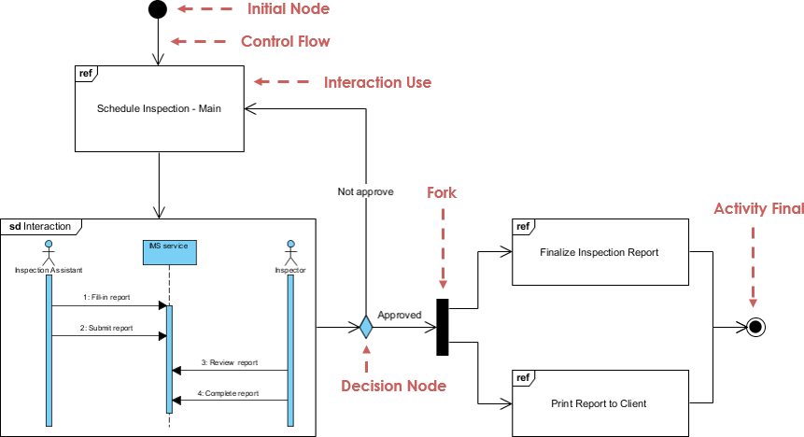
Figure 11: Interaction Overview diagram

Lab task :

- Draw a Class Diagram for Student and Course
- Create a Use Case Diagram for Course Registration

